Media Kit:

Forgotten Followers from Broken to Bold
New Historical fiction by local author Elaine R Kelly

Contents

Info Sheet for Retailers 2
Reviews: What readers are saying 3
Excerpts from Forgotten Followers 5
Author Photo and Bio: 6
Info Sheet for Podcasters/YouTubers 7
Suggested Interview Questions 8
Q & A 9
Feature Article: Local Author Launches Historical Fiction 13
PRESS RELEASE October 31, 2022 15
Event Flyer 16
PRESS RELEASE November 21, 2022 17

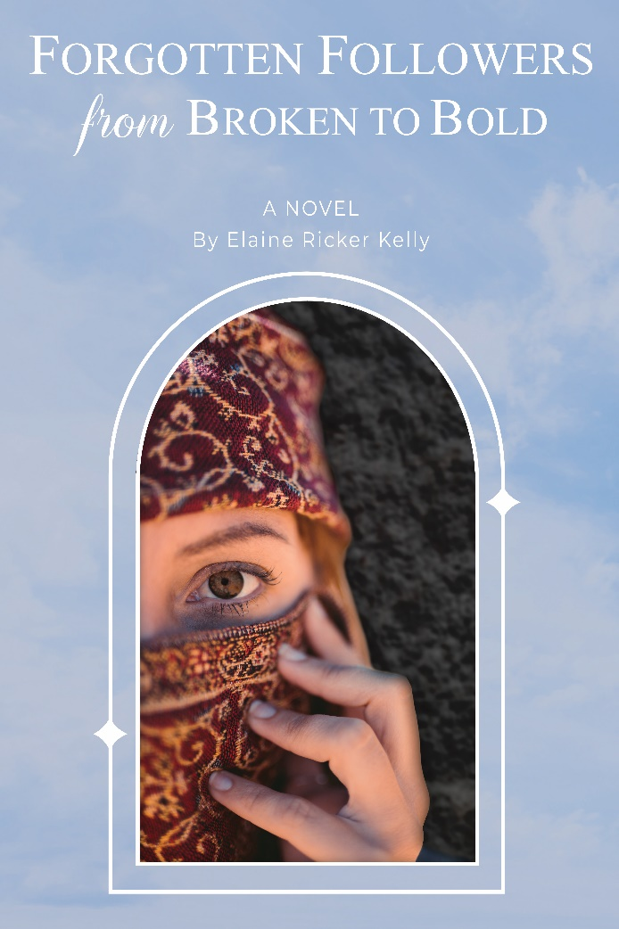
Info Sheet for Retailers: Forgotten Followers from Broken to Bold
by Elaine Ricker Kelly

After years of submission, Mara is afraid and unsure about everything—especially her nephew, Jesus. Then he is chased off a cliff, and Mara is forced into the unknown. At the same time, Joanna grapples with hiding her mixed-race heritage or losing her family and community. Despite trauma, abuse, racism, and inequality, they join other women disciples. Will Jesus’s opposition to the establishment endanger their lives?

Forgotten Followers brings love and encouragement to anyone who has felt alone, rejected, or simply out of place. Instead of dismissing women of the Gospels as unimportant, author Elaine Ricker Kelly lifts them up as empowered and vibrant characters. Whether evangelical, exvangelical, atheist, Catholic, Orthodox, Protestant, deconstructing or doubting, readers can find themselves in this historical fiction, the first novel in her Broken to Bold series.
“If you’ve ever felt like women are treated like secondary characters in God’s story, then let Forgotten Followers bring the many women who loved and followed Jesus to life! Such a refreshing, life-giving read to see how knowing
Jesus can free you from the cage you put yourself in—or that society puts yourself in. These fictional stories are grounded in amazing historical research—and made me see Jesus’ love for me in a whole new way.”
Sheila Wray Gregoire, author of The Great Sex Rescue and founder of BareMarriage
FICTION
Christian fiction, Historical fiction, Religious fiction,
Inspirational Fiction, Women In The Bible
300 pages, B/W, 6x9 inches
55% Wholesale Discount through Ingram
40% Retailer Discount through author
Elaine Ricker Kelly uses her experience as a woman in business to inspire and empower women at home, church, and society. She has been an investment and insurance advisor, has three daughters, and aims to encourage girls and women in leadership. Elaine R Kelly lives in Grimsby, Ontario, Canada, with her husband and their dog. She and her husband enjoy hiking, nature, tennis, music, history, and culture. They worship in the mainline Protestant Christian tradition.
Hardcover
978-1-03-914333-3
Retail List Price US$34.99 (C$45.50)

Softcover
978-1-03-914332-6
Retail List Price US$19.99 (C$26.49)

eBook
978-1-03-914334-0
Retail List Price US$5.99 (C$7.85)

Let’s Connect: www.elainekelly.ca
Twitter @Elaine_Kelly_author elainekellyauthor@gmail.com
Instagram @elaine_kelly_author Wholesale available through Ingram
Facebook @ Elaine Kelly Author Consignment available through the author

Reviews: What readers are saying

Captivating work of biblical fiction
Through the pages of this captivating work of biblical fiction by Elaine Ricker Kelly, we meet broken followers of Jesus, women whose lives have been damaged either through sexual abuse, anxiety, fear, racism, or demon possession. As these women live their daily lives in the presence of Jesus and his followers, the impact of his life and teachings becomes apparent through the experiences of the women with whom he interacted.
I highly recommend this novel to anyone looking for a fascinating work of biblical fiction, one that highlights the particular concerns of female contemporaries of Jesus and gives an opportunity to experience the great contrast between Jesus' take on the place of women with that of the prevailing order of the day.
This honest review was based on a complimentary Advance Reader Copy.
Elisabeth, Chapters-indigo kobo ebook review

Engaging
Reviewed in the United Kingdom on 14 September 2022
This engaging novel brings the Bible to life through the eyes of women. Biblical stories can be cheesy and devoid of conflict but here the author delivers realism and plenty of dialogue and opinions.
Through meticulous research, Elaine Ricker Kelly introduces us to a diverse cast of characters and adds historical details that open our eyes to often-unknown wider contexts of the era.
This honest review was based on a complimentary Advance Reader Copy.
Helen, Chapters-indigo kobo ebook review

Engaging and Thoughtful, a heart-warming, empowering Story
Story speaks truth to the heart. Better than any other novel I have read, Kelly’s imagination enables women of today to see themselves as beloved of God, as healed, chosen and sent by Jesus. With her extensive research into traditions, “Forgotten Followers” is a credible and very relatable unfolding of the gospel stories from the perspective of the women who accompanied Jesus during his three years of public ministry. You will read the Scripture differently once you have read this story. There are too many surprises in the story to begin to list them! I’d love to unpack some of these new perspectives in a study group for “Forgotten Followers”.
It was a bonus to read the Epilogue, in which Kelly lays out the traditions around which her characters are built, and the “facts, traditions and fiction” about Mara and Joanna, through whose eyes unfolds the story “Forgotten Followers, from Broken to Bold”.
This honest review was based on a complimentary Advance Reader Copy.
Laurie, Goodreads.com review

Forgotten Followers evens up the Gender Gap and makes Jesus a real person
When people think of disciples of Jesus, they generally think of men. Elaine Ricker Kelly shifts the focus to the women in his orbit. She tells the gospel story through their eyes. In some cases, these would be family members of Jesus and the characters Kelly fleshes out are all mentioned in the Bible. She has done meticulous research. But above all, she grapples with the emotional impact of having such a controversial figure in their midst. Today people preach sermons and devise theologies about Jesus. But, by writing it in the style of historical fiction, she brings home the fact that it is above all a story, a compelling one at that.
Mike, Amazon.ca reviewer

Inspiring!
As an atheist concerned about the plight of women as second-class citizens through the past 20 centuries, I was initially intrigued by this story because it transcends religion. “Forgotten Followers” addresses racial and gender inequality and in fact, brings to the forefront how men decided women didn’t even have sufficient intelligence to report on events. It elicits several responses to ponder well after finishing the story, as these women eventually rose above the constraints of their time. The author’s meticulous research, excellent writing and believable dialogue effectively change a familiar story in an unexpected and heartwarming way.
MM, Amazon .com reviewer

Very Impressed
Very impressed by this first time author. The amount of research is very evident. Her characters are very relatable. Sometimes I forgot that I was reading a fiction the way she blends her characters with biblical characters. As a man, it was a great insight on a woman’s point of view. I recommend this read and look forward to her next book.
Bill, Goodreads reviewer

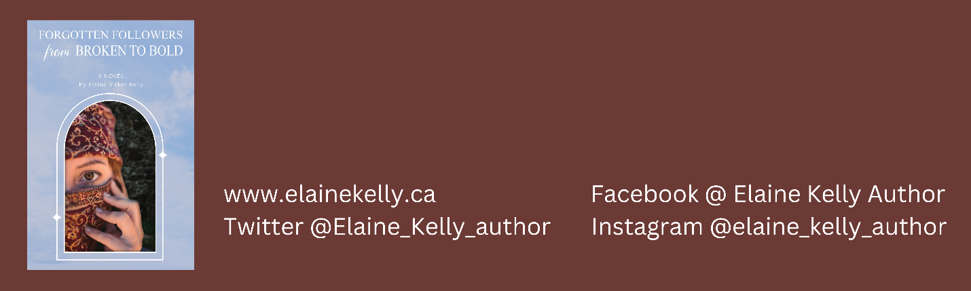

Excerpts from Forgotten Followers

Excerpt 239 words:
Despite her size, no one saw her. Mara had learned the hard way how to make herself invisible. Being seen or heard led to trouble. She rarely left her home. But that afternoon, Mara dropped her bread-making and went out. Her firstborn son Jamie had burst into her outdoor cooking courtyard, calling her to come right away. She banked the fire and left her baking in a cast iron pot over the embers in her brazier. She covered herself with a full-length robe and fastened it with her copper brooch. She pulled along nine-year-old Janis and six-year-old Simeon. Her eleven-year-old son, Joses, was apprenticing with his abba at the blacksmith shop. Mara soon fell behind, her chest heaving. As she reached Nazareth’s market square, she was embarrassed by her son’s enthusiasm.
“Has he done any miracles yet?” Jamie stretched on his tiptoes.
“No, he hasn’t,” replied the onlooker.
Mara kept silent, as always. She did not speak unless someone addressed her directly, did not speak in public, and definitely did not speak to men outside her family. Afraid of being judged by the religious leaders, she checked that her copper shawl pin closed her robe at the neck. She followed
the Jewish code of modesty to avoid drawing unwanted attention. Jamie seemed to expect his cousin to perform miracles. The onlookers expected it too. Mara knew better. She did not believe in miracles. Mara felt alone in the crowd.

Excerpt 131 words:
Men turned and looked up at the family and Mara blushed. She hated being in the spotlight. She fingered the copper brooch Clopas had crafted for her at his blacksmith shop. When they were newly married, she was embarrassed to undress in front of Clopas, ashamed of her body, afraid of pain in her marriage duty. She feared Clopas would divorce her, but he was patient and self-controlled. He told her their marriage was about more than the marriage bed and that he would be faithful. The copper shawl pin reminded her of how he protected her from pain and made her feel safe.
Maria saw Mara fidgeting nervously and whispered, “Don’t worry, this is our home. This is our family.”
But Mara replied, “I have a bad feeling. They rejected you once before.”

Author Photo and Bio:
50-word Bio:
Elaine Ricker Kelly uses her experience as a female financial advisor to inspire and empower women at home, church, and society. She and her husband have three grown daughters and enjoy hiking, tennis, and music. They live near Hamilton, Ontario and worship in the mainline Protestant Christian tradition.
125-word Bio:
Elaine Ricker Kelly uses her experiences as a woman in business to inspire and empower women at home, church and society. She was an investment and insurance advisor for thirty years, has three grown daughters, and is passionate about writing engaging fiction that encourages girls and women in leadership. Forgotten Followers from Broken to Bold offers hope and love to anyone who feels forgotten, belittled, or out of place. The main characters in this Christian historical fiction overcome trauma, abuse, and racism and begin to use their gifts boldly. Elaine R. Kelly lives near Hamilton, Ontario, Canada, with her husband and lap dog. She and her husband have hiked the 900 km Bruce Trail and enjoy hiking, nature, tennis, music, history and culture.

250-word Bio:
Elaine Ricker Kelly writes inspiring and empowering fiction using her experiences as a businessperson, volunteer, friend, daughter, sister, wife, mother, and grandmother. Women were a minority when Elaine began her career as an investment and life insurance advisor, but there was a strong movement towards equal rights and opportunities for women.
As she prepared to leave the financial industry, she realized women’s rights had actually been moving backwards, and some new gender restrictions seemed to be coming from the church. As a Christian, Elaine felt it was important for Christians to know that Jesus endorsed equal opportunities regardless of gender. ​ As a financial advisor, Elaine knew that Jesus engaged women as financial advisors. As a mother of three daughters, Elaine wanted Christians to know that Jesus equipped women as disciples and empowered women to speak and lead. Forgotten Followers from Broken to Bold features Mara, the wife of Clopas, recovering from abuse and Joanna, a financial patron of Jesus, grappling with racism.
​Elaine R Kelly Author also writes inspirational blogs on biblical equality, church history, and women leaders. She believes the Bible authorizes all believers to speak, act, or lead at home, in church, or in society.
Elaine R. Kelly and her husband live near Hamilton, Ontario, Canada with their lap dog. She and her husband have hiked the 900 km Bruce Trail and enjoy nature, tennis, music, history, and culture. They worship in the mainline Protestant Christian tradition.
For FAQ, blogs, and writing updates, please visit www.elainekelly.ca

Info Sheet for Podcasters/YouTubers
Elaine Ricker Kelly
Author of historical fiction empowering women
Located near Hamilton, Ontario, Canada
Available for Remote or face-to-face interviews
Categories:
- Biblical equality
- Gender equality
- Women in the first century
- Christian Theology about women’s roles today
Topics I can discuss:
Elaine Kelly will discuss insights from her research on:
- Authoritarian/gentle parenting
- Purity culture, modesty and being able to approach God
Background:
For her historical fiction, Elaine R Kelly has researched biblical themes of equality, ancient history and cultural norms, and theological perspectives on women’s roles in the Bible and today. In developing characters recovering from abuse and racism, Kelly can share her insights on some causes, impacts, and means of overcoming trauma. Having spent a career as a financial advisor, Kelly can also speak about her journey researching the craft of writing fiction and the power of story.
Previous Appearances:
Local Churchology discussion on women in ministry
Regency History on researching and writing historical fiction (soon to be released)
Media Coverage
The Hamilton Spectator November 26, 2022: A Christian-based novel addresses inequality and gender roles. ‘Forgotten Followers from Broken to Bold’ aims to bring healing and hope for readers.
- Anxiety, worry, and self-confidence
- Women of the Bible
- Jesus educating, equipping, empowering women
- Jesus extending and expanding the family of God to all races and ethnicities
- Genesis creation story and its impact on women
- Complementarian and Egalitarian perspectives on women’s roles
Benefits to your Podcast/YouTube Channel
- An informal, conversational tone, with complex concepts in everyday language.
- Content that is pertinent to audiences interested in Christianity or deconstructing their faith
- Promoting the finished interview on my website, email list, Twitter, Instagram, and Facebook
Let’s Connect:
www.elainekelly.ca
Twitter @Elaine_Kelly_author
Instagram @elaine_kelly_author
Facebook @ Elaine Kelly Author

Suggested Interview Questions

- Where did you get the idea to write a historical fiction around women in the first century?
- What motivated you to write this novel?
- Why put these ideas in a historical fiction?
- What first got you started in reading biblical fiction?
- What are the main themes that you explore in the book?
- Why did you choose to develop these particular women of the Bible?
- Which character do you relate to the most?
- When researching, what stood out about how women were viewed in the first century?
- How did your research change how you view a woman’s role?
- Who would enjoy reading this novel?
- Is there anyone else you think the book would resonate with?
- What advice would you give to those who are uncomfortable with changing their views?
- Is there any advice to women specifically as they wrestle with some of these things?
- What are your hopes for this book?
- What writing projects are next for you?

Q & A
Why write a historical biblical fiction? In short: I write to show that Jesus empowered women.
1. Where did you get the idea to write historical fiction about women in the first century?
I have always been interested in exploring the women of the Bible and during the pandemic, I had a chance to read, listen to, and explore more articles, podcasts, and research on the women of the Bible. I found models of strong women of faith, but many of them had either been forgotten or intentionally hidden or slandered. I have noticed through the years how girls and women are devalued in our culture, workplaces and churches. I have three daughters and have made an effort to empower them, build their self-esteem, encourage them to explore ideas, make their own choices, and develop their voices and their gifts. Once I had researched the women who interacted with Jesus, I thought other people, especially women, would be interested in getting to know these women who were eyewitnesses, patrons, disciples and apostles.
2. What motivated you to write this novel?
The United Nations had declared a Decade for Women from 1975 to 1985, and it looked like changes would address women’s rights, pay equity, and gender violence. Girls were told we could be anything we wanted to be. Women used their gifts in churches and more denominations were beginning to ordain women. My own mother frequently was a leader and speaker at events for Christian men and women and she was involved in supervising women interns as they prepared for ordination. In the 80s and early 90s, Canada, the UK, and India had their first woman prime minister. When I was a student in Western University’s business program, women were a minority but there was a cultural and societal trend towards equal rights and representation regardless of gender. As I prepared to retire after thirty years in the financial industry, I discovered that while I had been looking the other way, women’s rights had actually been moving backwards. As I looked for the source of reverse, I found that many of the new restrictions on women seemed to be coming from the Christian church. I felt betrayed – I am a Christian and had grown up thinking the Bible taught equality and yet the church was becoming an increasingly strong voice against equality. An urgency was placed on my heart to write about how Jesus endorsed equality, taught women as disciples, hired them as his financial advisors and commissioned women to go out and speak.
3. Why put these ideas in historical fiction?
Theologians, scholars, and academics have already written many books outlining how Jesus lifted up women and explaining how the Bible can be interpreted to promote equality. This is important in changing our thinking, but I believe stories and characters are the keys to changing our actions. Jesus used stories in his teaching: fictional stories that reveal true ideas. I see biblical fiction as a parable. I enjoy putting complex ideas into plain language and I believe historical fiction connects to our emotions and makes concepts more accessible. A story impacts the heart, which can change people’s behaviour in ways that intellectual knowledge cannot. We saw this with Uncle Tom’s Cabin, by Harriet Beecher Stowe. Uncle Tom’s Cabin is a fiction that dramatically showed the problems of slavery. While theologians and politicians used intellect to argue about slavery, this novel used storytelling and emotion to motivate the public toward abolition. In my financial career, we learned that facts tell, and stories sell. People could think about products, concepts, and strategies, but did not usually take action until they felt in their hearts that a financial idea would give them peace of mind or a feeling of security or some other benefit. I believe historical fiction can change people’s minds about gender equality.
4. What first got you started in reading biblical fiction?
Likely the one that got me started on biblical fiction Michal, by Jill Eileen Smith. I was struggling with infertility at the time and was depressed that some Bible passages connect this physical ailment with sin or disobedience. I was affirmed to see Michal not being sinful and weak and punished with infertility for being immoral. Instead, the novel shows Michal is brave when she hides a statue under blankets to help David escape; strong when she is at her father King Saul's mercy after David flees; wise when she counsels David to show respect before God and the Ark; faithful even when David moves on to other wives. It makes you wonder how many women have been portrayed as sinful and weak when they were really strong, positive models of faith.
5. What are the main themes that you explore in the book?
I explore how the Bible empowers all people to follow their call and use their gifts, regardless of gender. Mary’s song of praise prophesies that Jesus will lift up the lowly and pull down the powerful. The church today has done just the reverse, revering the powerful, silencing the lowly and separating people based on gender or race. Authoritarian hierarchies of control, promoting the ideas that women are there to be used, to serve men, to be silent and submit to mistreatment, have borne the fruit of harm and abuse. My novel explores universal themes of inequality, abuse, and racism.
6. Why did you choose to develop these particular women of the Bible?
My novel shows twelve women who acted as disciples and learned from him. They seemed to be chosen, called, equipped, and sent out as apostles. In thinking of women who interacted with Jesus, many people can only spontaneously think of Jesus’s mother Mary, and Mary Magdalene. I include 35 women of the Gospels in my novel, and focus on 12: Mary the mother of Jesus, Mara of Clopas, Salome the mother of James and John, Perpetua the wife of Peter, Mariamne the sister of Philip, Veronica who is healed of bleeding, Photini the woman at the well, the patrons Joanna, Susannah, Mary Magdalene, and the sisters Mary and Martha. My novel follows the character arcs of two women, and I tell the story from their viewpoints: Mara of Clopas, who is traumatized by abuse, and Joanna, who is hiding her mixed heritage due to racism.
7. Which character do you relate to the most?
Probably Mara – she is the character who is most deeply developed and there are some things about me that you can see in her. Like her, I sometimes listen to the negative and ignore the positive. It takes some effort for Mara to learn to take a compliment and believe in herself. Like many readers, Mara is filled with doubt about whether God sees them, chooses them, or loves them.
8. When researching, what stood out about how women were viewed in the first century?
I came into the research thinking women were second-class in the first century. I learned that they actually had some rights: the right to own property or business in certain situations, the right to inherit in the absence of a male relative, the right to have no male guardian if they had three or more children, and the right separate or divorce in certain situations. My research showed where Jesus talks about marriage and divorce in Matthew 19, it wasn’t really about limiting divorce to situations with unfaithfulness but more about calling men to be accountable to uphold their vows to love their wives. I spent quite a bit of time examining the sermon on the mount and how turning the other cheek has been used to keep women in abusive situations. I read about women survivors who shared their journeys about how God wants us to seek shelter and protection.
9. How did your research change how you view a woman’s role?
I came into the writing already thinking of women and men as equals and believing in equal rights and opportunities. My views on Jesus changed, though, as I saw how much Jesus lifted up women and turned paternalistic cultural ideas upside down. The Old Testament shows women were prophets, judges, military leaders, and strong influencers even though the times were patriarchal. If you look at how Jesus treated women, and what Jesus is telling us about his worldview, it is that all people are treated as equals, regardless of gender, ability, or another characteristic. We need to see the rest of the scripture and the letters of Paul through that lens.
10. Who would enjoy reading this book?
Probably those who would relate to it and enjoy it the most are those who have doubts about God, Christianity, or the church. They will relate to the main character, Mara, whose experiences have made her doubtful and fearful. The novel portrays real people, with various hopes, disappointments, anger and conflicts. Anyone who is disappointed in the church's tendency to limit what women may do will enjoy it. Those who are upset that the church has hidden scandals or sexual abuse and supported abusers while ignoring victims will feel vindicated. The novel shows this behaviour is wrong and unlike Jesus. The novel will affirm people who feel unloved by God, excluded, or sidelined by the church. Writing this story forced me to reexamine my ideas and some of the church's pat answers or teachings. Anyone who is deconstructing their beliefs, has left the church or considers themselves an ex-vangelical would enjoy the novel's fresh take on the Gospel stories.
11. Is there anyone else you think the book would resonate with?
Along with those who are doubting or deconstructing their faith, others who would appreciate this novel include:
a) Anyone who has been silenced or sidelined, such as women gifted to be leaders or speakers, and men who have been forced into a restrictive macho role. Those who have been limited will be lifted up.
b) Anyone who feels broken or hurt by the church or religion, or has been judged, or made unwelcome. This includes people who are LGBTQ, single, divorced, victims of abuse, and people of colour. The novel shows Jesus’s example of affirmation and love.
c) Women who want to see themselves in the gospels and who are looking for female models of faith. I hope to bring them healing and hope.
d) Those who have enjoyed non-fiction books on religion and gender, Christian women’s issues, egalitarianism, and feminist theology.
e) Any pastors, clergy, or religious leaders who want to understand the feelings and views of people who have left the church and are open to seeing biblical stories in a fresh, inclusive light.

12. What advice would you give to people who are uncomfortable with changing their views?
We need to have a respectful, open conversation about the place of women in the Bible and in our churches so that we can work together for the good of everyone. I hope that by telling what the women saw, heard, and experienced, the reader will be able to decide for themselves what they think about how Jesus valued all people.
13. Is there any advice to women specifically as they wrestle with some of these things?
If a woman feels she has no voice or is not respected, then I think she has to get out of that situation and go to a place where people do listen to her. All human beings are made in God’s image, share God’s creative qualities, reflect God’s personality and are given unique talents and traits. I would encourage women to know they are co-heirs with Jesus and co-heirs with men and that God shows no favouritism and treats us all equally. If you feel threatened, you may need to get an advocate who can help you to perceive things in a different way so that you can get to safety.
14. What are your hopes for this book?
I hope to reach as many people as possible with a healing message that Jesus opposes inequality in his teaching and example. I dream of a time when Christians will lead instead of lagging in the movement toward equality regardless of gender, race, orientation, ability, or any other characteristic.
15. What writing projects are next for you?
I will soon be publishing The Sword, a book of 104 flashcards with various understandings of biblical passages supporting healthy debate on what the Bible says about a woman's role. I am finishing up a ten-session interactive study guide for Forgotten Followers, which examines the themes of the novel. Forgotten Followers from Broken to Bold is the first in a series about women leaders in the Bible and early church. Book 2 is Forgotten Apostles, which begins at the stoning of Stephen. Susannah escapes to her Palestinian suppliers in Caesarea and interprets the prophecies of her four daughters. Joanna flees to Antioch and joins an active community of Greek believers. They commission Joanna to travel using her Latin name, Junia, and she becomes an outstanding apostle.

Feature Article: Local Author Launches Historical Fiction

When Elaine Kelly started her career in investments and life insurance, women were in the minority, but The United Nations had declared a Decade for Women from 1975 to 1985, and it looked like changes would address women’s rights, pay equity, and gender violence. As she eased back from her financial career, she was amazed to find that equal rights for women had moved backwards. During the pandemic, women’s workforce participation dropped to its lowest level in thirty years (1). What’s more, some of the push for limitations on women came from the Christian world. As a Christian who had seen women in leadership roles in the past, she felt betrayed. She knew Jesus himself had accepted support from female financial advisors and patrons. Having three daughters, Kelly had taught them about women of the Bible who God gifted and called to various roles. As Kelly explored how Jesus endorsed equality, equipped women as disciples and empowered women to speak and lead, she decided to write a story to share these affirmations, especially for women who feel devalued.
Forgotten Followers from Broken to Bold tells the stories of Mara, traumatized by abuse, and filled with doubts and insecurities. Research for Mara’s character led Kelly to story after story of survivors of gender-based violence and financial, emotional, and spiritual abuse. The other main character, Joanna, grapples with racism, feels undeserving of her success and position, and hides who she really is for fear of being ostracized. A quote from the back cover shows that Kelly was successful in her aim to bring healing and hope:
“These fictional stories are grounded in amazing historical research--and made me see Jesus' love for me in a whole new way." —Sheila Wray Gregoire, author of The Great Sex Rescue and founder of BareMarriage

Elaine Ricker Kelly and her husband live in Grimsby and enjoy hiking, tennis, and music. Forgotten Followers is in eBook and physical form at books.friesenpress.com and all online stores. You can get the paperback locally at The Nook, 42 Main St. West, Grimsby. Kelly is hosting a Book Launch Party at Station 1 Coffeehouse on Sunday, November 30th at 3:00 pm. RSVP to: elainekellyauthor@gmail.com.
Take a Taste:
Men turned and looked up at the family, and Mara blushed. She hated being in the spotlight. She fingered the copper brooch Clopas had crafted for her at his blacksmith shop. When they were newly married, she was embarrassed to undress in front of Clopas, ashamed of her body, and afraid of pain in her marriage duty. She feared Clopas would divorce her, but he was patient and self-controlled. He told her their marriage was about more than the marriage bed and that he would be faithful. The copper shawl pin reminded her of how he protected her from pain and made her feel safe.
Maria of Nazareth saw Mara fidgeting nervously and whispered, “Don’t worry, this is our home. This is our family.”
“I have a bad feeling. They rejected you once before.”

- https://canadianwomen.org/the-facts/women-and-pandemics/

Let’s Connect: www.elainekelly.ca
Twitter @Elaine_Kelly_author elainekellyauthor@gmail.com
Instagram @elaine_kelly_author Wholesale available through Ingram
Facebook @ Elaine Kelly Author Consignment available through the author

PRESS RELEASE October 31, 2022
FOR IMMEDIATE RELEASE: FORGOTTEN FOLLOWERS FROM BROKEN TO BOLD
Local Author Elaine Ricker Kelly writes Christian fiction endorsing gender equality
[Grimsby, Ontario, Oct 31, 2022] Is it culture or Christianity that devalues women, their roles, promotions, pay, and power? Elaine Kelly investigated whether women in the Bible were limited or lifted up. Does the Bible help or harm those who advocate for equal rights regardless of gender? Kelly brings her experience as a female financial advisor and a mother of daughters to turn upside down the idea that the Bible restricts women to certain roles, functions, or positions based on their gender. Her novel affirms women as valuable and worthwhile, authorized with the same rights and opportunities as men.
After years of infertility, Kelly was over the moon to have daughters. But some said it be wonderful or for her and her husband to have a boy. Kelly has noticed our culture’s preference for sons and the idea that a son is needed for a “million-dollar family.” Like many girls and women, the main character of Kelly’s novel, Mara, knows she is worth less than others; her low self-esteem and lack of confidence means everything seems too risky – even speaking or leaving the home. After years of trauma and abuse, Mara is immobilized by fear.
Only 15-25% of financial advisors are females, and after decades as an investment and life insurance advisor, Elaine Kelly was excited to find that Jesus engaged female financial advisors and patrons. One of these was Joanna, a key character in Kelly’s historical fiction. Kelly employs Joanna’s character to address themes of racial equality.
After years of submission, Mara is afraid and unsure about everything—especially her nephew, Jesus. Then he is chased off a cliff, and Mara is forced into the unknown. At the same time, Joanna grapples with hiding her mixed-race heritage or losing her family and community. Despite trauma, abuse, racism, and inequality, they join other women disciples. Will Jesus’s opposition to the establishment endanger their lives?
"If you've ever felt like women are treated like secondary characters in God's story, then let Forgotten Followers bring the many women who loved and followed Jesus to life! Such a refreshing, life-giving read to see how knowing Jesus can free you from the cage you put yourself in--or that society puts yourself in. These fictional stories are grounded in amazing historical research--and made me see Jesus' love for me in a whole new way."
—Sheila Wray Gregoire, author of The Great Sex Rescue and founder of BareMarriage

Forgotten Followers, produced by FriesenPress, is available for order from most major online book retailers, including the FriesenPress Bookstore and Amazon. The eBook is available at Amazon Kindle, iTunes Bookstore, Chapters/Indigo Kobo and GooglePlay. The paperback is available locally at The Nook, 42 A Main Street West in Grimsby. A book launch celebration will be held Sunday November 20th from 3:00 – 5:00 pm at 24 Steps Lounge, Station One Coffeehouse, 28 Main St. East, Grimsby. RSVP to the author to attend the launch event.
About the Author
Elaine Ricker Kelly uses her experience as a female financial advisor to inspire and empower women at home, church, and society. She and her husband have three grown daughters and enjoy hiking, tennis, and music. They live in Grimsby, Ontario and worship in the mainline Protestant Christian tradition.
Contact: Elaine Kelly Phone: 289-775-8885
Email: elainekellyauthor@gmail.com Website: www.elainekelly.ca

Event Flyer

Before Event:
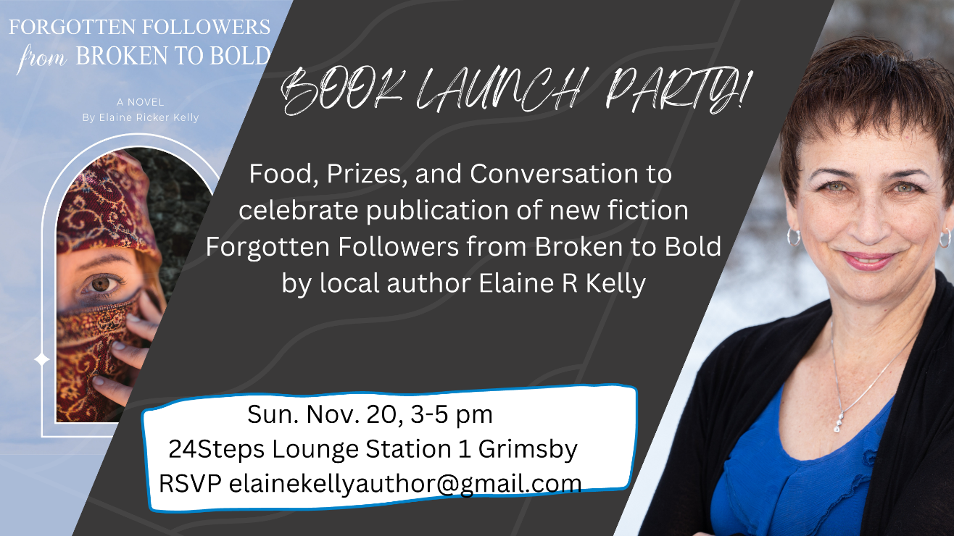

During Event:
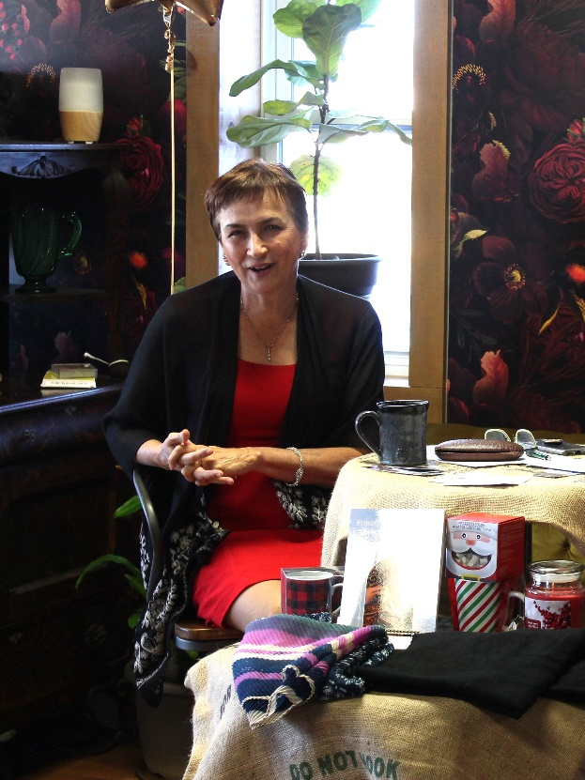

PRESS RELEASE November 21, 2022
FOR IMMEDIATE RELEASE: FORGOTTEN FOLLOWERS FROM BROKEN TO BOLD
Local Author Launches Historical Fiction Addressing Inequality and Gender Roles
[Grimsby, Ontario, Monday, Nov 21, 2022] It was a cheerful group of supporters that shovelled out of the snow to come to the Book Launch at Station 1 in Grimsby on Sunday afternoon. For Elaine Kelly, it was a moment to celebrate the accomplishment she has been working towards for over two years: the publication of her new historical fiction Forgotten Followers from Broken to Bold.
Guests enjoyed refreshments and live music played by the author’s husband, David Kelly. Their daughter, Lynn Doxtater, led an interview where Kelly discussed her motivations and goals for writing a novel about women in the first century. Kelly reflected on how the Roman Empire allowed women some rights to divorce, to receive and manage financial inheritances, and gain freedom from male guardianship. After the interview, Kelly cut into a cake topped with icing in the design of her book’s front cover, and guests munched and mingled.
“It was so gratifying to feel support and encouragement for me and my project. Writing can be a lonely activity, so it was wonderful to hear conversations bubbling all around the room as people shared stories of strong women who overcame difficulties and used their voices. They appreciated me, as a Christian, speaking out against the church limiting women’s choices, roles, or freedoms. We have a responsibility to use our gifts and to speak boldly.” – Elaine Kelly
Kelly was in the minority when she began her career as a female financial advisor, but it looked like women’s rights were moving forward. Thirty years later, she found gender equality had moved backwards. Kelly knew Jesus himself had female financial advisors and patrons and Kelly had taught her three daughters about gifted women of the Bible who performed a variety of roles including speaking and leading. She set about writing an engaging biblical fiction featuring Mara, traumatized by abuse, and Joanna, grappling with racism. Forgotten Followers from Broken to Bold shows Jesus lifting up women, educating, equipping, and empowering them. Kelly believes that fiction impacts the heart in ways that logic and theology cannot, and she hopes her book brings healing and hope to those who have felt marginalized by the church.
A quote on the back cover shows Kelly was successful in her aim:
“These fictional stories are grounded in amazing historical research--and made me see Jesus' love for me in a whole new way." —Sheila Wray Gregoire, author of The Great Sex Rescue and founder of BareMarriage

Forgotten Followers, produced by FriesenPress, is available for order from most major online book retailers, including the FriesenPress Bookstore and Amazon. The eBook is available at Amazon Kindle, AppleBooks, Chapters/Indigo Kobo and GooglePlay. The paperback is also at The Nook, 42 A Main St. W., Grimsby.
About the Author
Elaine Ricker Kelly uses her experience as a female financial advisor to inspire and empower women at home, church, and society. She and her husband have three grown daughters and enjoy hiking, tennis, and music. They live in Grimsby, Ontario and worship in the mainline Protestant Christian tradition. For more on Kelly’s writing, visit www.elainekelly.ca
Contact: Elaine Kelly Phone: 289-775-8885
Email: elainekellyauthor@gmail.com Website: www.elainekelly.ca

